Uncovering Metabolomic Complexity in Neural Stem Cells
While the brain only makes up 2% of a person’s overall body weight, it commandeers 25% of our glucose consumption and 20% of our oxygen consumption to power neural cell activity [1]. However, the fuel requirements for neural stem/progenitor cells (NSPCs), which retain the capacity to produce new neurons and glia in the adult mammalian brain [2, 3], are less well understood. Researchers from the laboratory of Doug M Turnbull (Newcastle University, UK) took on this challenge, and discovered that mouse NSPCs are capable of using multiple energy sources but rely on upon fatty acid oxidation to support aerobic respiration and proliferative activity [4]. They suggest that this knowledge may lead to the development of methods to metabolically control adult neurogenesis in the injured or aged central nervous system.
Initial analyses found the expression of factors required for fatty acid metabolism (medium chain acyl-CoA dehydrogenase (MCAD) and trifunctional protein (TFP)) in cells of both the subventricular zone (SVZ) and hippocampal dentate gyrus (DG), which represent sources of adult neurogenesis from NSPCs. SOX2 is well known as a marker of progenitor cells, and while there was no overlap with MCAD expression in the hippocampal DG, there did exist a large proportion of overlap in the SVZ. MCAD expression in the SVZ did not however express Ki67, a proliferative marker, suggesting that actively proliferating cells do not undergo fatty acid oxidation. Assessment of metabolic gene expression during cellular maturation of NSPCs using laser capture microdissection found an alteration in the metabolic profile of differentiating cells. Specifically, they found that adult-born neurons and glia acquire lactate transport machinery but do not lose the ability to carry out fatty acid oxidation.
The group then measured oxygen consumption rate (OCR) in response to various substrates and demonstrated that while NSPCs do metabolize glucose, they are not fully dependent upon glucose to sustain aerobic respiration. The addition of the polyunsaturated fatty acid linoleic acid significantly increased OCR in NSPCs even in the presence of glucose, while inhibition of fatty acid oxidation blocked the proliferation of NSPCs without affecting apoptosis in vitro. In vivo analyses found, as expected, that inhibition of fatty acid oxidation decreased the proliferation of SVZ cells, but not hippocampal DG cells.
A reduction in aerobic respiratory activity in NSPCs is associated with aging [5] and so, lastly, the study sought to understand if boosting respiratory activity could boost neurogenesis and rescue regenerative activity. Overexpression of Peroxisome proliferator-activated receptor Gamma Co-activator 1 alpha (PGC1α) induces mitochondrial biogenesis and an increase in aerobic metabolic capacity, and the group found that lentiviral-mediated PGC1α induction in cultured NSPCs from the aged mouse brain led to an increase in respiratory capacity and proliferative activity (See figure - Induced MCAD and Ki67 upon PGC1α expression). However, they saw no differences in the propensity of cells to survive or undergo neuronal differentiation.
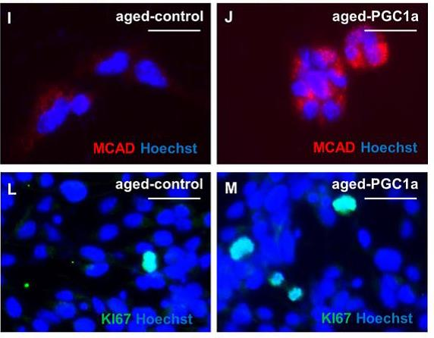
This study suggests that alterations in diet may affect neurogenic activity via metabolic fuel availability, and, therefore, the modification of cellular “fuel” may allow us to regulate cellular proliferation in the injured or aged central nervous system. Further studies are first required to assess in detail the metabolic needs required for specific sub-populations of NSCs, as is highlighted by the differences observed in the assessment of NSPCs from the SVZ and the hippocampal DG, and also to understand whether any metabolically mediated changes to NSPCs can enhance cognition in animal models.
References
- Magistretti PJ and Pellerin L Cellular mechanisms of brain energy metabolism and their relevance to functional brain imaging. Philos Trans R Soc Lond B Biol Sci 1999;354:1155-1163.
- Kuhn HG, Dickinson-Anson H, and Gage FH Neurogenesis in the dentate gyrus of the adult rat: age-related decrease of neuronal progenitor proliferation. The Journal of neuroscience : the official journal of the Society for Neuroscience 1996;16:2027-2033.
- van Praag H, Kempermann G, and Gage FH Running increases cell proliferation and neurogenesis in the adult mouse dentate gyrus. Nature neuroscience 1999;2:266-270.
- Stoll EA, Makin R, Sweet IR, et al. Neural Stem Cells in the Adult Subventricular Zone Oxidize Fatty Acids to Produce Energy and Support Neurogenic Activity. Stem Cells 2015;33:2306-2319.
- Stoll EA, Cheung W, Mikheev AM, et al. Aging neural progenitor cells have decreased mitochondrial content and lower oxidative metabolism. The Journal of biological chemistry 2011;286:38592-38601.

